User Manual

Shopping Cart:

Zen Smoothie

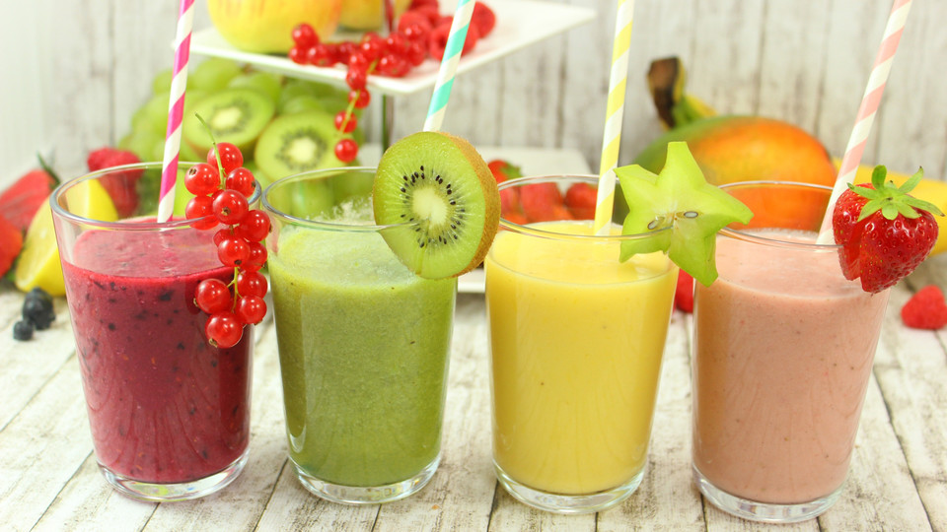

Ciara Butler

Nadera Harris

Guilibaldo "Willy" Uriostegui

**Welcome to Zen Smoothie**

*“Life is like a smoothie, you get out what you put in”*

**Step 1.**

Enter the Zen Smoothie Site

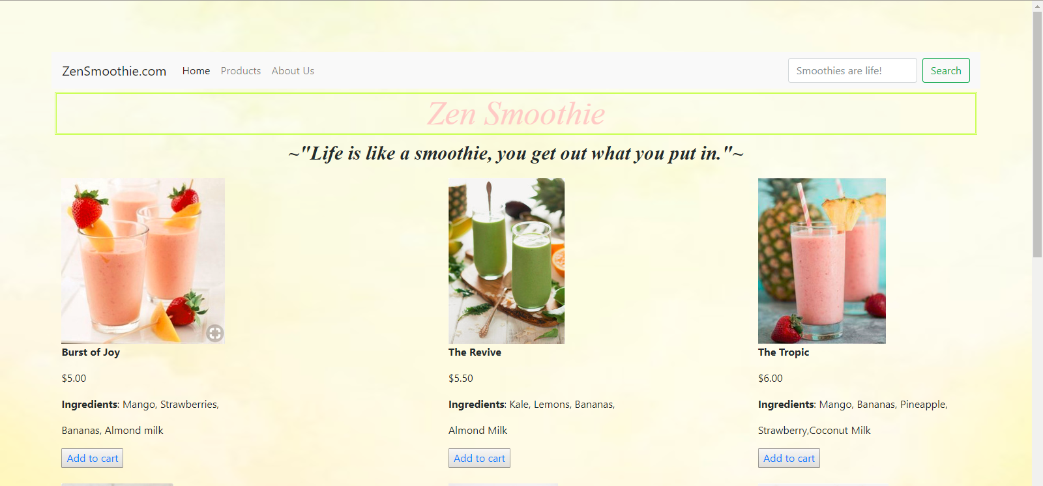

**Step 2.**

Select a smoothie of your choice

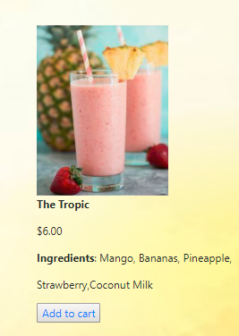

**Step 3.**

Click Add to Cart

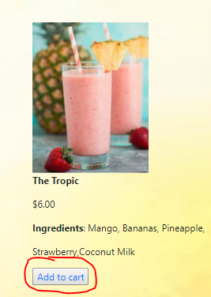

**Step 4.**

Scroll down the page to the Shopping Cart



**Step 5.**

Click checkout & enjoy



**Adding additional items to the cart or removing:**

Click the increase (+) or decrease (-) button to change the quantity of the smoothies



**Remove items from the cart:**

Click the Remove button at the bottom of the page



**Clearing Cart:**

Click the Clear cart button to empty the entire cart



**Method of Payment:**

* If the total price of the cart exceeds $100 you MUST pay with a credit card

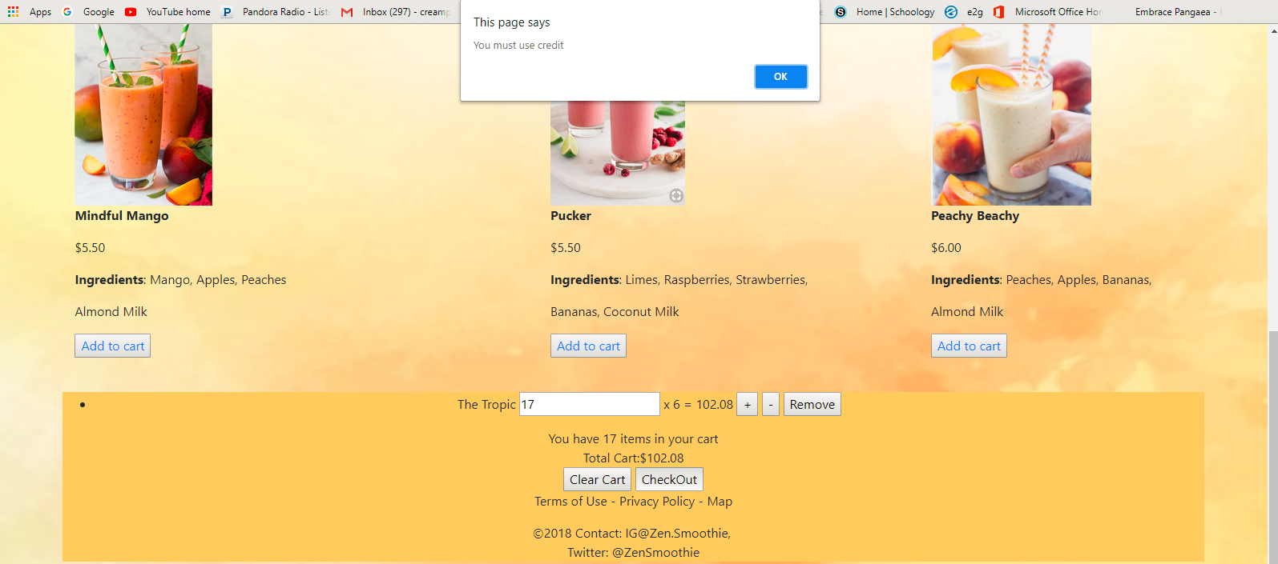

* If the total price of the cart is less than $100 you MUST pay with cash

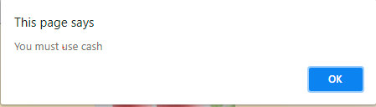

**Sales Tax:**

7.5 % sales tax will be added to the final price